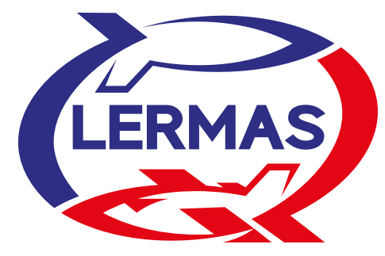
SLOVAK AEROSPACE MODELLING ASSOCIATION
RC MODEL KLUB MARTIN
Member of the Fédération Aéronautique Internationale
Preliminary Entry Form
2022 FAI F3K World Championship for Hand Launch Gliders
24th July – 29th July 2022, Martin – Slovakia
NAC_______________________________________________________________________

Name: ____________________________________________________________________

Address: __________________________________________________________________

Phone: ________________________________e-mail:_____________________________

National team

- Team Manager ____________
- Assistant Team Manager ____________
- No. of Senior Competitors F3K ____________
- No. of Female Competitors F3K ____________
- No. of Junior Competitors F3K ____________
- No. of Junior Female Competitors F3K ____________
- No. of Helpers / Supporter ____________
- Reigning Senior World Champion ____________
- Reigning Junior World Champion ____________

TOTAL PARTICIPANTS ____________

Date: ______________

Signature: ____________________ Official NAC Stamp ____________________

Preliminary Entry Form has to be sent before April 30th, 2022 via:
e-mail: rcmodelklub@gmail.com
filled at website: www.rcmklub.sk
or facebook: https://www.facebook.com/rcmklub

